# JAVA Intro

On Terminal:

NCT:~ Tracksta6$ java -version

java version "1.8.0_111"

Java(TM) SE Runtime Environment (build 1.8.0_111-b14)

Java HotSpot(TM) 64-Bit Server VM (build 25.111-b14, mixed mode)

Downloaded NetBeans IDE 8.2

Now With Netbeans. We will show how to start a project by just creating a class. This is not actually creating an application.

1. Top left, middle folder, gold-folder with a +: New Project
2. Categories: Select ‘Java’
3. Projects: Select ‘Java Class Library’
4. Name your project: circle (lowercase)
5. Current it is auto-stored in:
   1. Project Name: circle
   2. Project Location: /Users/Tracksta6/NetBeansProjects
   3. Project Folder: /Users/Tracksta6/NetBeansProjects/ circle
6. Click Finish
7. Top left menu:
   1. Down arrow Source Packages
      1. Right Click <default packages>
         1. Select New
            1. Select Java Class Wizard

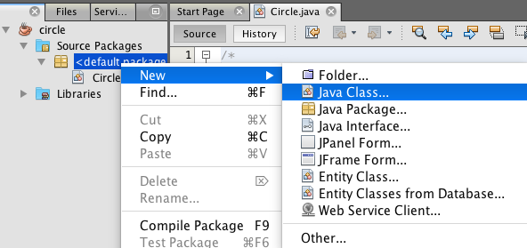

1. Now it will take us to the Java Class window.
2. First, name the Class Name the same as the project name. This isn’t a rule, but it is the process that the instructor is giving.

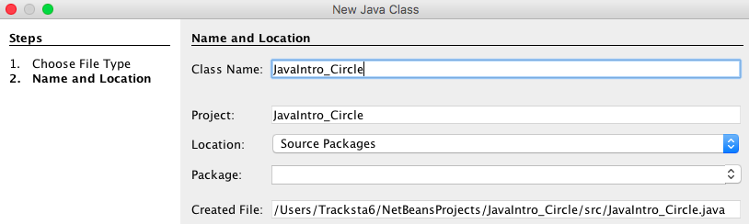

1. Change that class name and leave everything else as default.
   1. Note we changed the Class name to just “Circle”
   2. We have the next 2 screenshots that shows the original name before we simplified the project to “circle” and class to “Circle”
2. That will then take us to the editor, which has the opener for a class and the inherent starter comments.

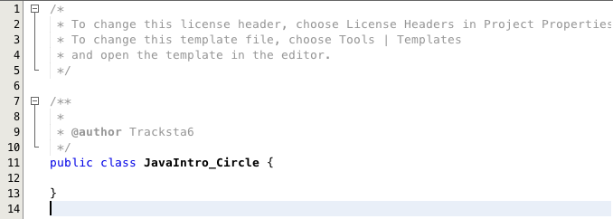

1. Now we have to make the main application.
2. Now go back to the <default package> folder: right click: New: Java Class Wizard: Name the Class Name: Main: Finish.
3. In the top left menu, under the <default package> selection, we now have 2 classes:

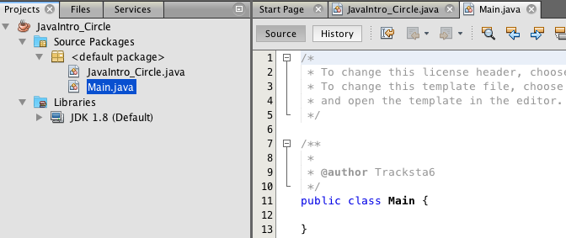

1. In the Main Class type:
   1. psvm + tab: to get this:

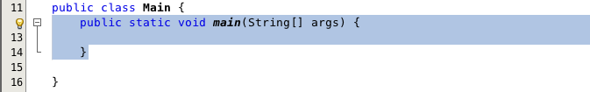

1. This allows us to run the application here in main.
2. Create a new circle entity using this class.
3. Print out that circle + a statement.

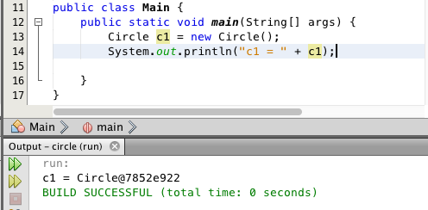

1. Note, Java only seems to accept double-quotes.